Park Tudor Chemical Database Troubleshooting Manual

Jason Zhao, Chris Gregory, Michael Xu

Table of Contents

Manual & Tutorials

Navigation

Editing the Database

Adding an Entry

Deleting an Entry

Editing an Entry

The Settings Page

The Labeling Page

The Mobile Site

Manual & Tutorials

Navigation

1. Navigating to the Desktop Site

To reach the desktop site, visit: <http://cs.parktudor.org/projects/ptcd/Home.aspx>. Once the page has loaded, you will be prompted for the site password. Enter the site password to continue to the home page. If you do not know the site password, go to the FAQ section for help.

1. The Home screen

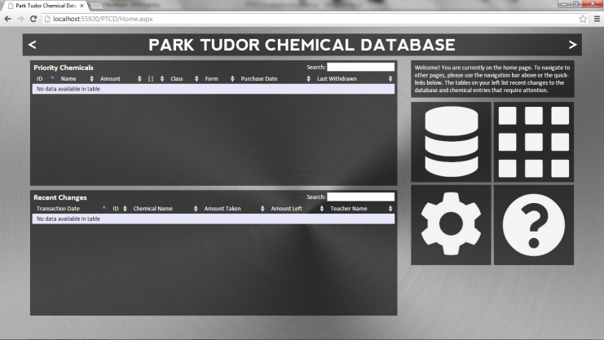The home page of the desktop site is formatted such that there is a navigation bar at the very top with left and right arrows that is used to navigate to the “About” page (the left arrow) and to the “Database” page (the right arrow). Clicking an arrow will bring you to its respective pages. On the right hand side of the home page are also four quick-link icons. Clicking the database icon (top-left) brings you to the database page, the label icon (top-right) brings you to the labeling page, the cog icon (bottom-left) brings you to the settings page, and the question mark icon (bottom-right) brings you to the about page.

1. The Database Page

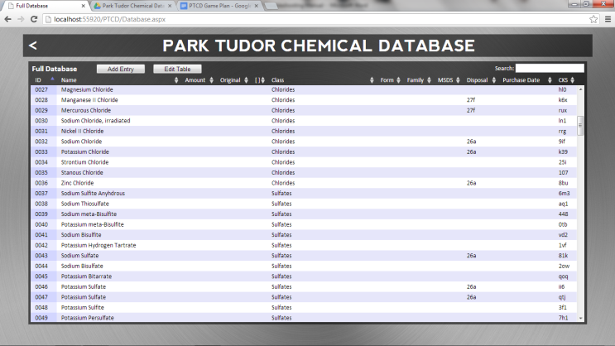This page contains a list of every chemical in the database along with information like class, form, family, etc. This page is for viewing and parsing through the chemicals, but not for editing. The table on the page is scrollable; to sort chemicals, click the field headers at the top of the field you want to sort by. You can also search the table by typing in a string in the search box on the top-right of the table. To add a chemical, click the “Add Entry” button. To edit the database, click the “Edit Table” button. These buttons will bring you to their respective pages. To learn how to use the pages please go to the How to Edit the Database section. To return to the home page, click the left arrow on the navigation bar at the top of the screen.

1. The About Page

The about page contains general information about the site, how to contact us, and how to locate certain pages like the labeling page. It also contains a link that allows you to change the desktop site password. To access any of the documents and site links, simply click on the corresponding orange “here”. To return to the home page, simply click the right arrow on the navigation bar at the top of the screen.

Editing the Database

1. Adding an Entry

To get to the Add a Chemical page, go to the Database page and click the “Add Entry” button. Once on the page, you will be presented with a form to fill out. You must fill out all required (all but the two optional) fields before the program will allow you to add the chemical to the database. Entering a short-date (MM/DD/YYYY) for the Purchase Date field is recommended, but entering in a checksum is not recommended. Once you have filled out all of the required fields, hit the submit button. If the entry was successful, a message will appear above the two buttons at the bottom of the form notifying you that the entry was successfully added. You can repeat this to add multiple entries or click cancel to return to the database page.

1. Deleting an Entry

To delete a chemical, go to the Database page and click on the “Edit Table” button. You will be brought to a page that looks similar to the Database page except that on the left-hand side of the table there will be a link that says “Delete” that gives you the option to delete the entry on that row. Simply click the delete link to delete the entry on that row. Click the left arrow on the navigation bar at the top of the screen to return to the Database page.

1. Editing an Entry

To edit a chemical, go to the Database page and click on the “Edit Table” button. Similar to the delete function, to edit a chemical entry, simply click the “Edit” link on the left-hand side of the table. The text in the selected row will change into editable text boxes. After making the necessary changes, simply click the “Update” link on the left hand side to save the changes. Alternatively, click the “Cancel” link to discard the changes you made.

The Settings Page

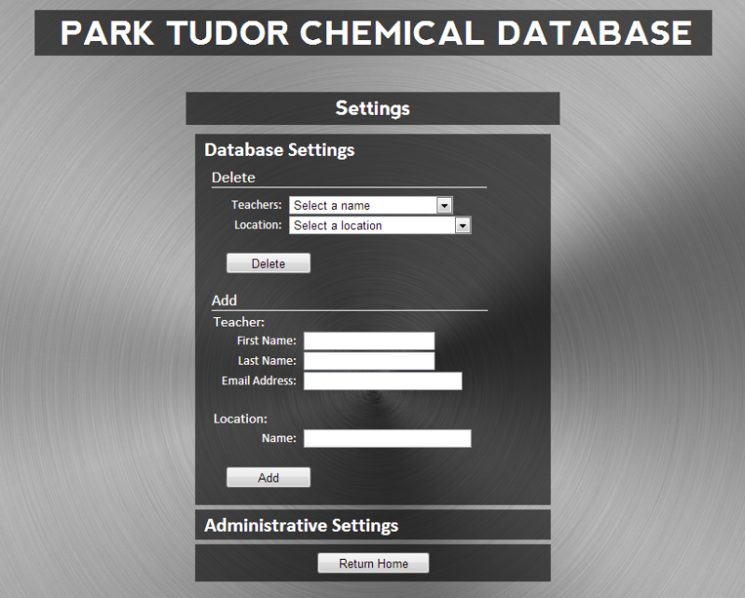 The settings page is accessed by clicking the cog icon on the homepage (bottom left item in the navigation bar area). At the settings page, there are two collapsible forms: one for database settings, and the other for administrative settings. To add/delete a teacher or location, hover over the “Database Settings” title bar until the form expands (if not already expanded). Simply select the locations or teacher you want to delete a click the “Delete” button to delete them from the database. Fill in the forms to add new teachers or locations and click the “Add” button to add them to the database. To change the site password, hover over the “Administrative Settings” title bar until the form expands, and follow the instructions.

Troubleshooting

Frequently Asked Questions (FAQ)

Q: What browser is recommended for use with PTCD?

A: Google Chrome, download here: <https://www.google.com/intl/en/chrome/browser/>



Q: How to do access the desktop (administrator) site?

A: Follow this link: <http://cs.parktudor.org/projects/PTCD/Home.aspx>



Q: What is the desktop (administrator) site password?

A: The current science department chair sets the password. Only he/she can access the site.

Contact Information